H2 DATATBASE installation

- Open Google type as H2 database

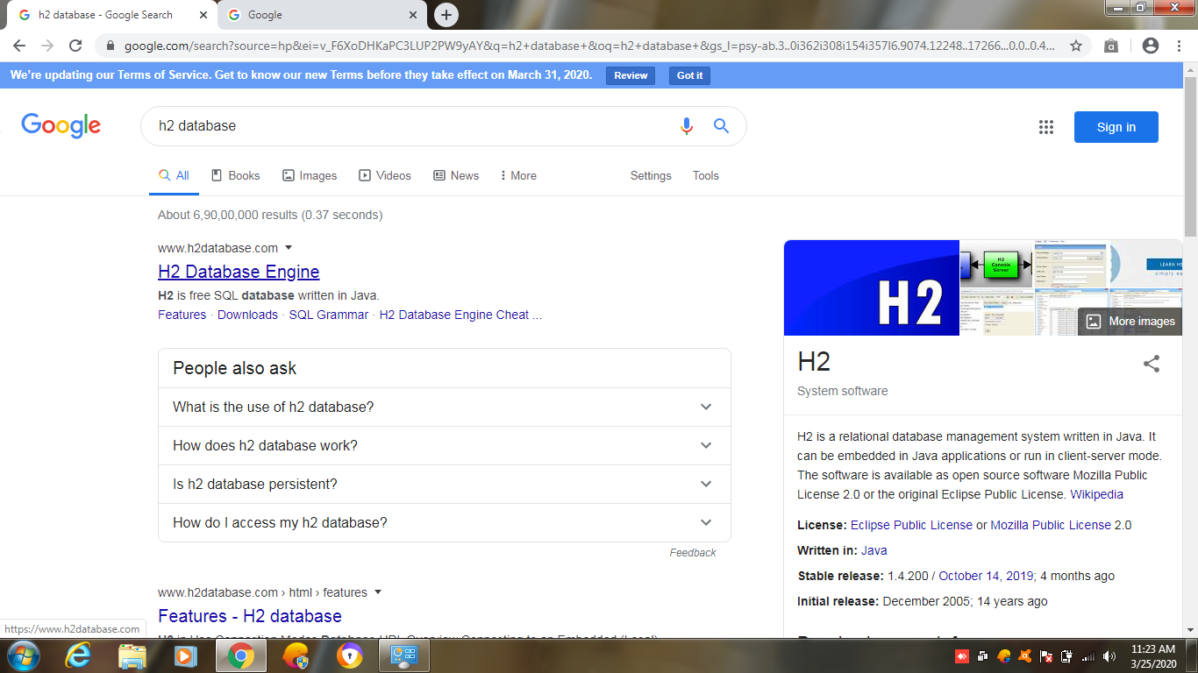

Click on Windows Installalor or all platforms.zip
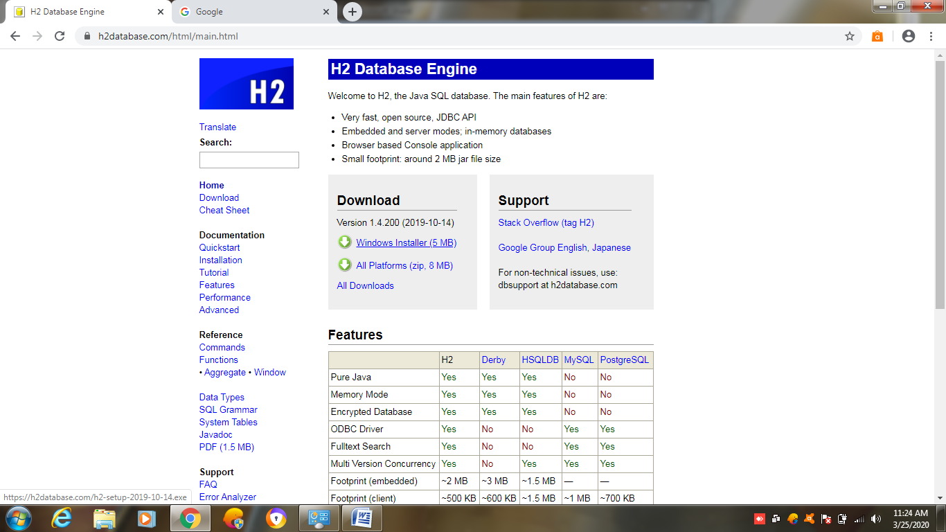

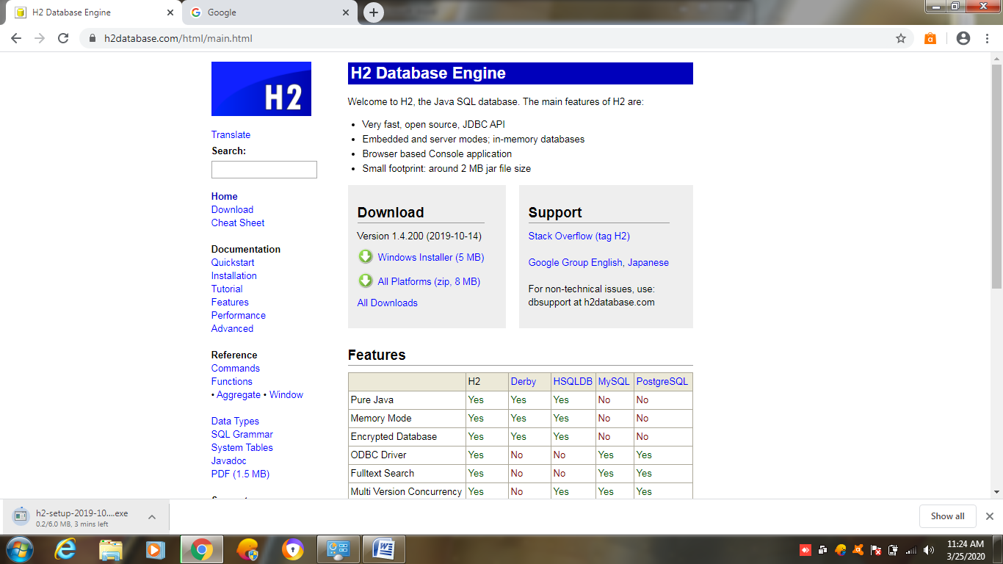

Double click on downloaded .exe or extract zip folder


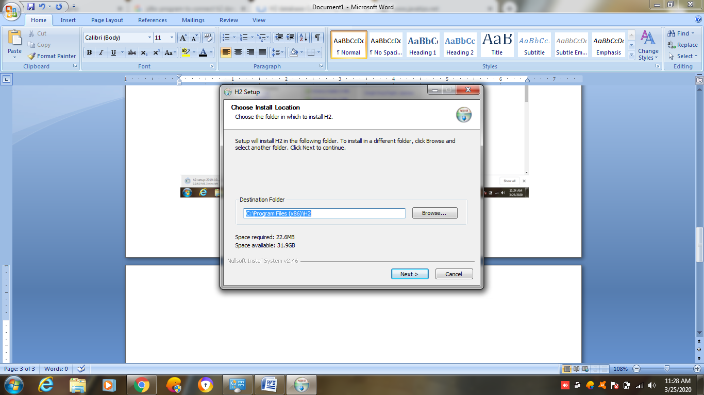

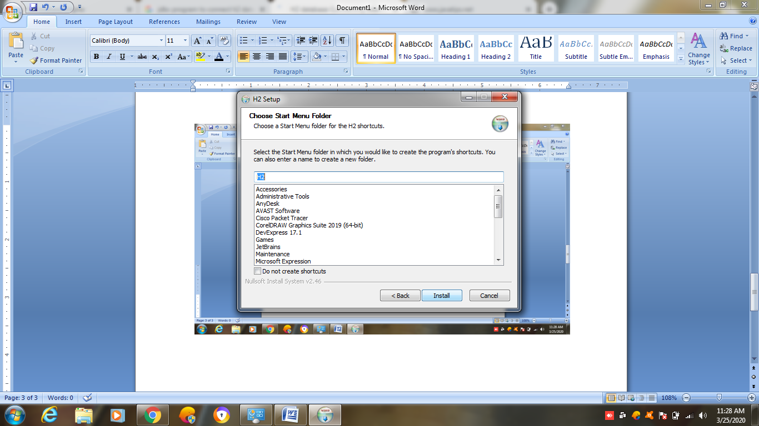

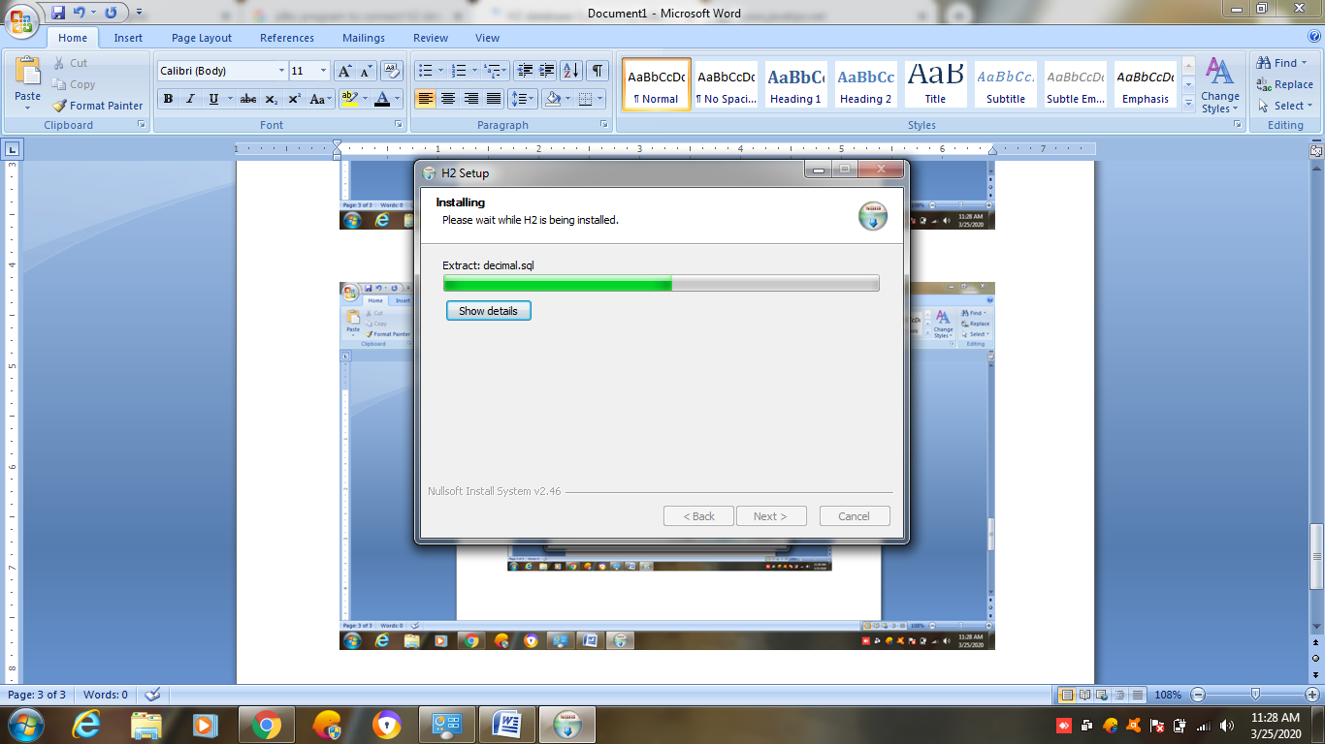

Once installed got c:\program files(x86) folder
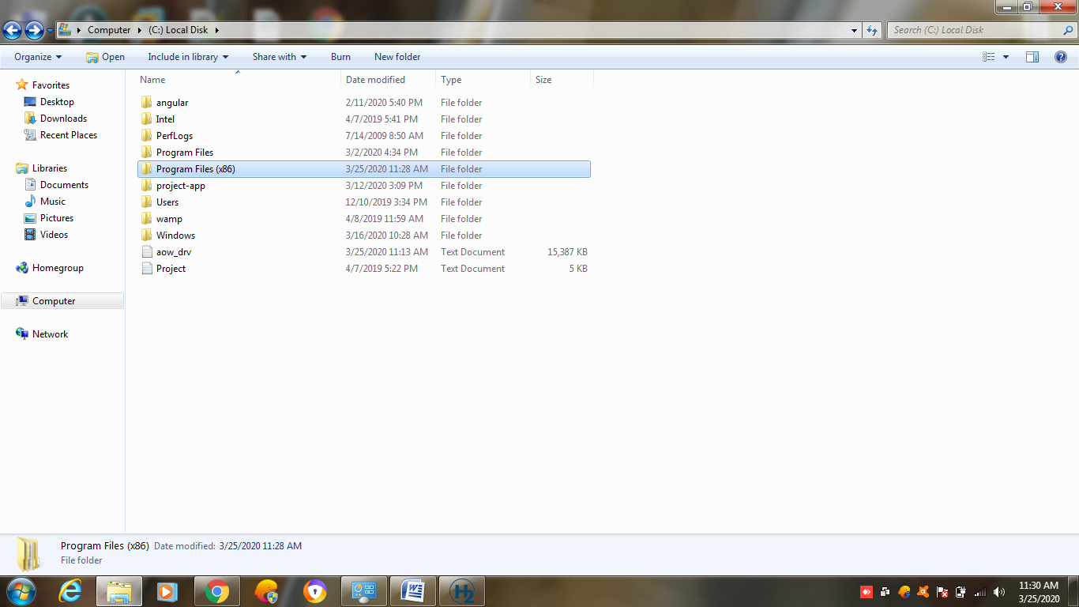

Double click on H2 Folder

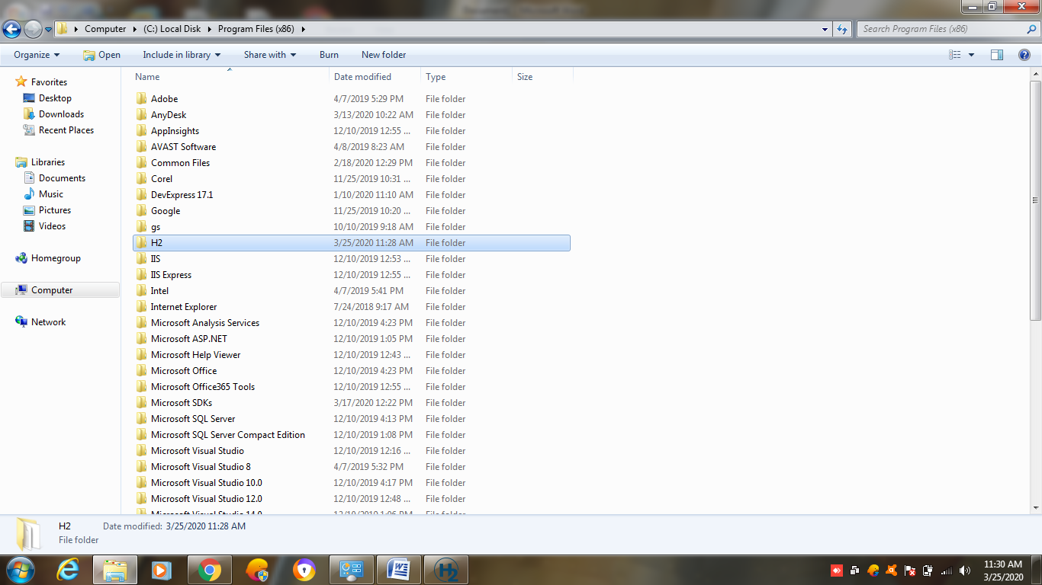
Double click on bin folder
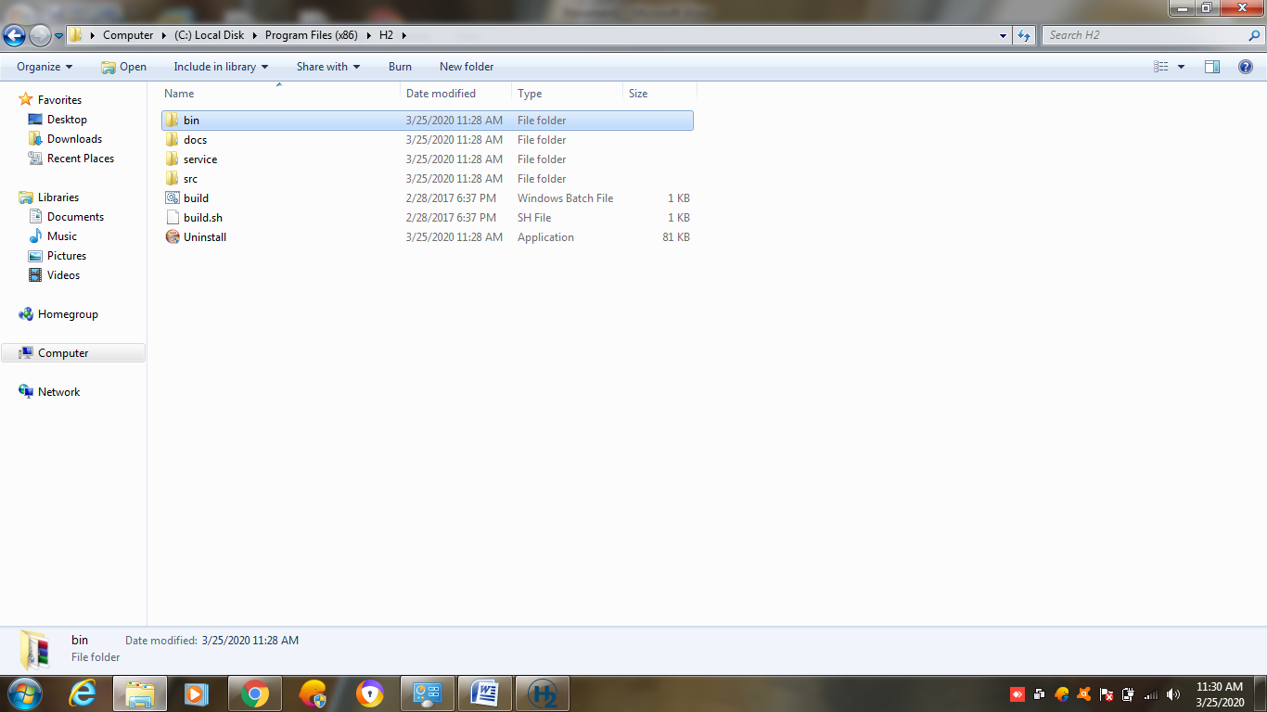

Click on h2w . exe file

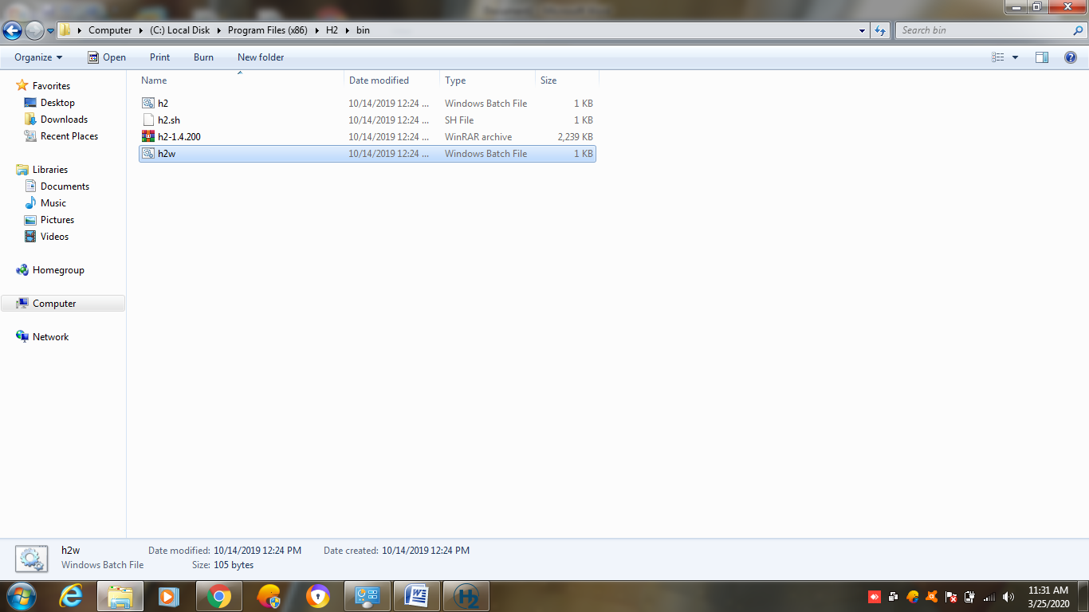

JDBC (Java DataBase Connectivity)
This concept is used to connect any database and we can perform the database manipulations.
Like CRUD(Create, Read, update and Delete).

There are 5 steps to connect any java application with the database using JDBC.

These steps are as follows:
- Register the Driver class
- Create connection
- Create statement
- Execute queries
- Close connection

1) Register the driver class
The forName() method of Class class is used to register the driver class.

Example for oracle
Class.forName("oracle.jdbc.driver.OracleDriver");

2) Create the connection object
The getConnection() method of DriverManager class is used to establish connection with the database.

Example to establish connection with the Oracle database
Connection con=DriverManager.getConnection( "jdbc:oracle:thin:@localhost:1521:xe","system","password");

3) Create the Statement object
The createStatement() method of Connection interface is used to create statement. The object of statement is responsible to execute queries with the database.

Example to create the statement object
Statement stmt=con.createStatement();

4) Execute the query
The executeQuery() method of Statement interface is used to execute queries to the database.
This method returns the object of ResultSet that can be used to get all the records of a table.

Example to execute query
ResultSet rs=stmt.executeQuery("select * from emp");

while(rs.next()){
System.out.println(rs.getInt(1)+" "+rs.getString(2));
}

5) Close the connection object
By closing connection object statement and ResultSet will be closed automatically.

Con.close();

Java Database Connectivity with Oracle

- Driver class: The driver class for the oracle database is oracle.jdbc.driver.OracleDriver.
- Connection URL: The connection URL for the oracle10G database is jdbc:oracle:thin:@localhost:1521:xe where jdbc is the API, oracle is the database, thin is the driver, localhost is the server name on which oracle is running, we may also use IP address, 1521 is the port number and XE is the Oracle service name. You may get all these information from the tnsnames.ora file.

Java Database Connectivity with MySQL
To connect Java application with the MySQL database, we need to follow 5 following steps.
In this example we are using MySql as the database. So we need to know following informations for the mysql database:
- Driver class: The driver class for the mysql database is com.mysql.jdbc.Driver.
- Connection URL: The connection URL for the mysql database is jdbc:mysql://localhost:3306/sonoo where jdbc is the API, mysql is the database, localhost is the server name on which mysql is running, we may also use IP address, 3306 is the port number and sonoo is the database name. We may use any database, in such case, we need to replace the sonoo with our database name.
- Username: The default username for the mysql database is root.

To connect java application with the mysql database, mysqlconnector.jar file is required to be loaded.
download the jar file mysql-connector.jar

